GOLDEN TRIANGLE TOUR
Destinations Covered: Delhi – Agra – Jaipur – Delhi
Duration: 05 Nights / 06 Days

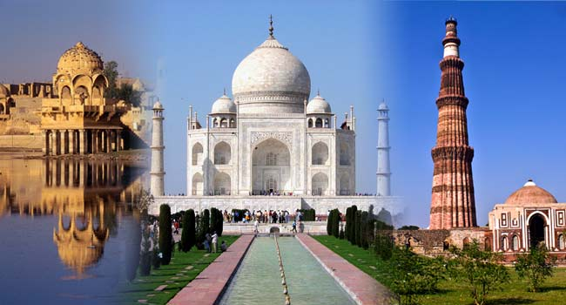

Overview:
India's Golden triangle is a classic tour that comprises of India's most popular cities. Have an incredible escapade to Delhi, Agra & Jaipur and create a cherishable vacation exploring UNESCO World Heritage sites, majestic forts and palaces, bustling markets and savouring sumptuous Indian cuisine. Begin and conclude your journey in the capital city, Delhi, where you will experience the perfect blend of modern era's contemporary style & the medieval era's grandeur. Go to the stunning city of Jaipur and marvel at the century old forts and palaces and drive to a former city of the Mughals and see the stunning Taj Mahal in Agra.

Highlights:
- Explore the sprawling and culturally diverse Delhi
- Visit the 73-metre tall Qutub Minar
- Explore the first garden mausoleum, Humayun's Tomb
- Drive past the gigantic Mughal fortress, Red Fort
- Make your way through the narrow bylanes of Old Delhi in a rickshaw
- Witness the glory of Taj Mahal with an evening view
- Explore the huge expanse of the Agra Fort and learn about its Mughal architecture
- Learn about the history of the abandoned town of Fatehpur Sikri
- Take an elephant ride to the majestic 16th century Amber Fort
- Explore the colourful and captivating city of Jaipur - a UNESCO World Heritage Site
- Know the history behind the city’s century-old structures like City Palace
- Walk through the ancient observatory around Jantar Mantar
- Stop at the magnificent Hawa Mahal and click photos with the Palace as a backdrop.
- Visit World Heritage Sites in Delhi, Agra & Jaipur

DETAILED ITINERARY:

DAY 01: ARRIVAL IN DELHI

Upon arrival at Delhi International Airport, our representative will meet you and assist you in transfer to your hotel. Check-in at the hotel on arrival and relax.

Delhi - India's capital and major gateway to the country, contemporary Delhi is a bustling metropolis, which successfully combines in its fold, the ancient and the modern. Delhi unwinds a picture rich with culture, architecture, human diversity, history, monuments, museums, galleries, gardens and exotic shows. Comprising of two contrasting yet harmonious parts, the Old Delhi and the New Delhi, the city is a travel hub of Northern India. Delhi is a bliss for history lovers.

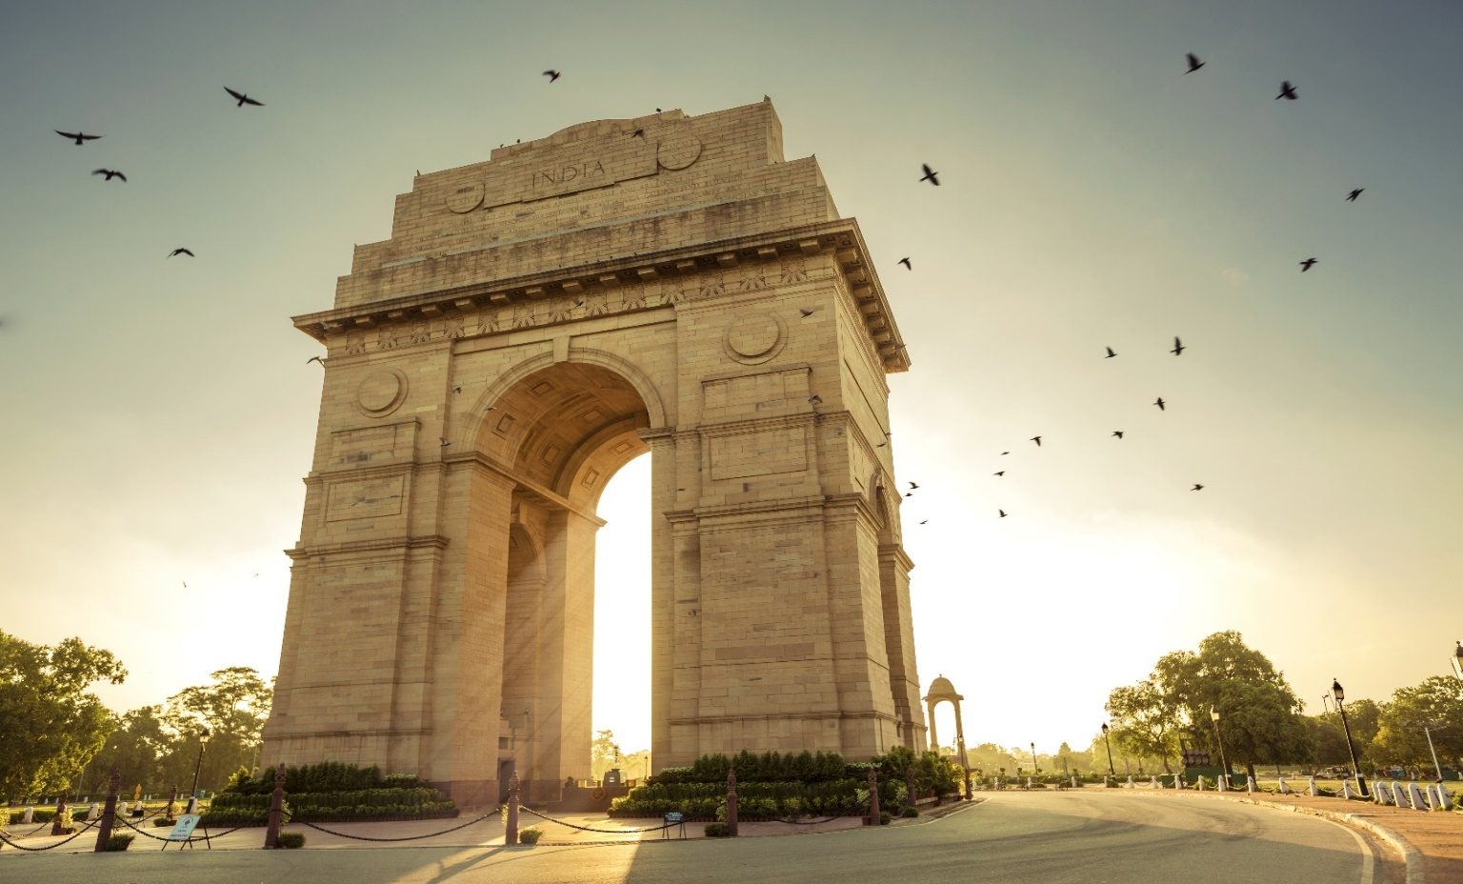

Overnight at hotel in Delhi.

DAY 02: DELHI SIGHTSEEING

After breakfast, proceed with Delhi sightseeing tour with first visit to Jama Masjid - the largest Mosque in India. Visit Chandni Chowk – oldest, biggest bazaar of Old Delhi. Walk up to Fatehpuri Masjid and enjoy a rickshaw ride till Red Fort. Here our driver will meet you and drive past Red Fort to reach Rajghat, a memorial where Mahatma Gandhi was cremated. An eternal flame burns on one side of this memorial. Also visit India Gate, President House, Parliament House drive past and here you can take some pictures.
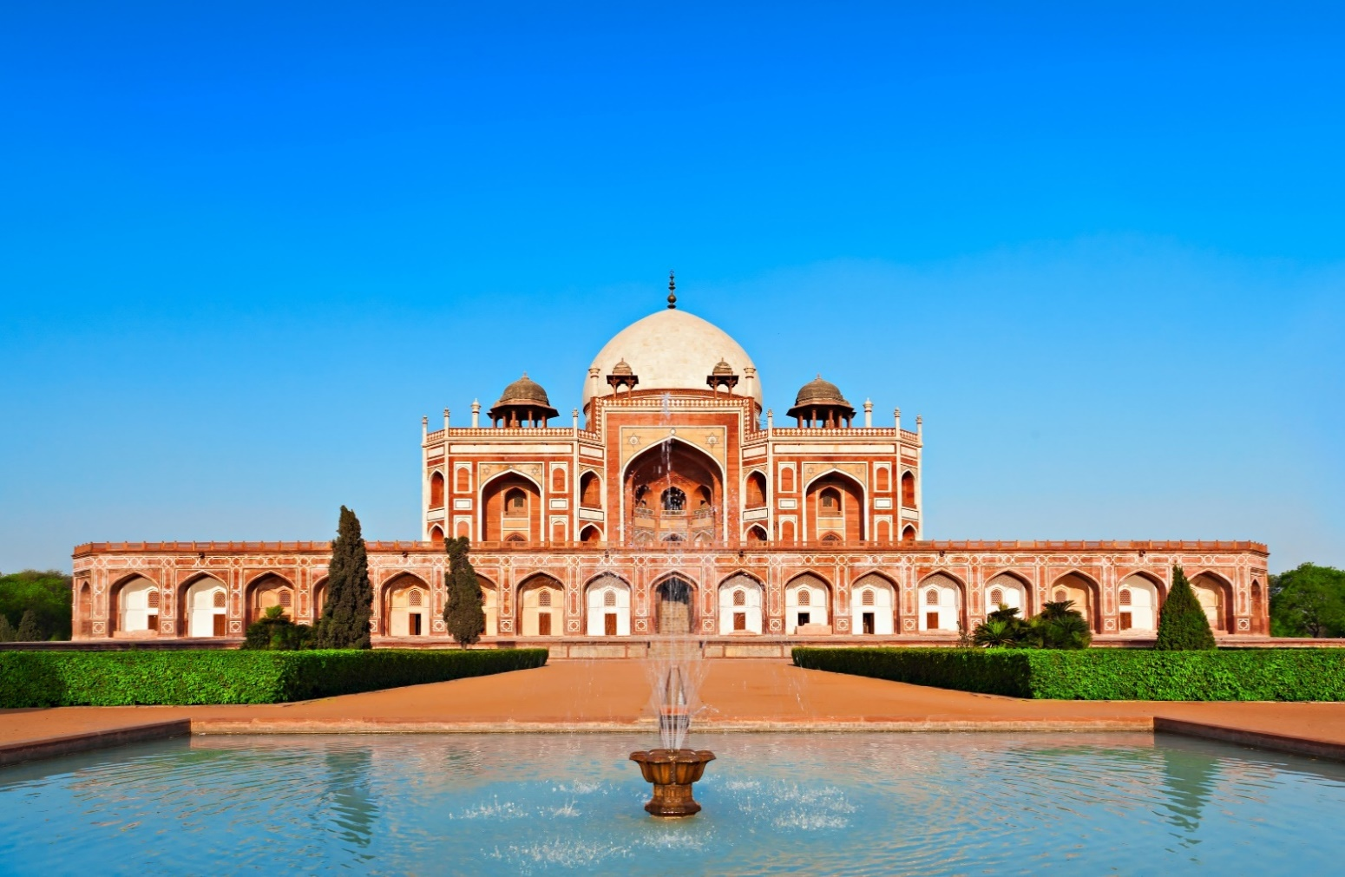
Visit the Humayun’s Tomb - first garden-style tomb of India. The main highlight of this tomb, inspired by Persian architecture, is the four garden squares with water passage channels surrounding the tomb. Visit Qutub Minar built by Qutab-ud-din Aibak in 1193 to mark the beginning of Muslim rule in India.

Overnight stay at hotel in Delhi.

DAY 03: DELHI - AGRA (210 KM/APPROX. 4-5 HRS)

After breakfast, you will head to Agra. Agra - a wonderful former city of the Mughals, home to the famous Taj Mahal. Upon arrival, check-in at the hotel.

After some relaxation, visit the Agra Fort - the seat and the stronghold of the Mughal Empire under successive generations.

Later in the evening, pay visit to the Taj Mahal. The Taj Mahal, which is one man’s monumental testimony to love, has become synonymous not only with this city, but with all of India. A mausoleum built by Shah Jahan for his empress Mumtaz Mahal, the Taj is the primary attraction of the city. Watching sunset over this iconic monument, is truly a sight to behold.

Overnight stay at hotel in Agra.
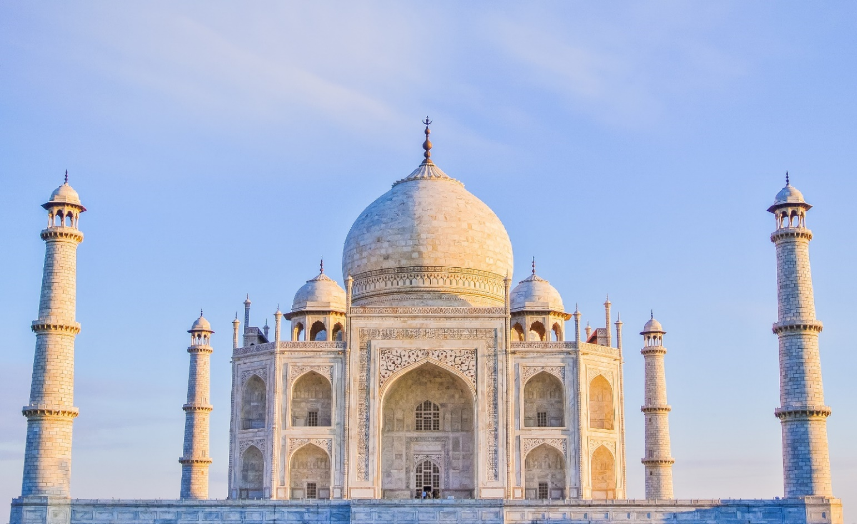

DAY 04: AGRA - JAIPUR (240 KM/APPROX. 5-6 HRS) VIA FATEHPUR SIKRI

Post breakfast and check out, drive to the beautiful city of Jaipur, also known as the Pink City of India. En route visit Fatehpur Sikri. Built by Emperor Akbar in 1569, Fatehpur Sikri was abandoned after 15 years due to scarcity of water. See the graceful buildings including Jama Masjid, Tomb of Salim Chishti, Panch Mahal and other palaces.

Continue drive to Jaipur. Upon arrival, check-in at the hotel. Jaipur: Jaipur is a city known as the Pink City of India due to extensive use of pink sandstone in various buildings of the city. Its monuments showcase a myriad of architectural styles and its vibrant bazaars are famous for traditional handicrafts and jewellery. The ambiance of this city speaks volumes of the rich lifestyle of the Rajput Kings.

Overnight stay at hotel in Jaipur.

DAY 05: JAIPUR SIGHTSEEING

After an early morning breakfast, we’ll take you to the magnificent Amber Fort, the former capital of the royal Rajputs. Set on the dry, craggy Aravalli Hills, and surrounded by fortified battlements, the palace straddles two sepia-hued tundra hills overlooking Maota Lake. Ride up to this hilltop palace on a caparisoned elephant, passing through the ancient main gate where the Maharajas of Jaipur have entered for four hundred years.

Later, take a stop to photograph the beautiful Hawa Mahal or Palace of the Winds; a five-storied structure of pink sandstone with semi-octagonal and delicately honeycombed windows overlooking the main street of the old city. It was built in 1799 so that veiled royal woman could peer down unseen by the world through its 953 ornate stone screens. Also see the City Palace; constructed by Maharaja Sawai Jai Singh II, this 19th century palace exhibits an exquisite blend of Rajput and Mughal architectural styles and features exquisite palaces and buildings. Next stop is Jantar Mantar, again built by Sawai Jai Singh II, which is an astronomical observatory exhibiting architectural astronomical instruments.

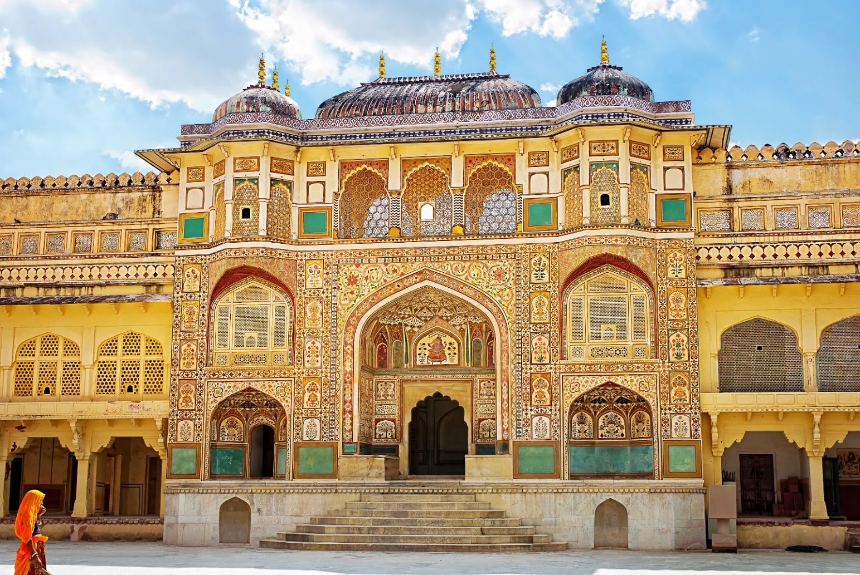
No tour is complete without a little bit of shopping. So in the evening, now proceed to Jaipur Bazaars to experience the local culture and explore the shopping hub Jaipur is famous for. Explore the streets and stores of Jaipur and take a piece of India back home. Jaipur is the central hub for shopping in India. The dazzling bazaars of this hypnotic city are flooded with textiles, footwear, ready-made garments, antique jewels, artefacts, bandhini print, carpets, pottery, marble curios and book, a mind-boggling collection of other exciting items.

Overnight at hotel in Jaipur.

DAY 06: JAIPUR – DELHI (280 KM/APPROX. 5-6 HRS)

After breakfast, check out from the hotel and drive to Delhi airport to catch the flight for your own ward destination.

“END OF THE TOUR”

HOTELS ENVISAGED
CITY | 3 STAR HOTELS | NIGHTS
NEW DELHI | SURYA INTERNATIONAL | 2
AGRA | ATULYAA TAJ | 1
JAIPUR | YASH REGENCY | 2

PRICING FOR 03 ADULTS

03 STAR HOTEL COST

BASED ON TRIPLE SHARING BASIS: INR 20,500 PER PERSON

YOUR TOUR PACKAGE INCLUDES:

- 5 Nights’ Accommodation as per the mentioned or similar hotels.
- Daily buffet breakfast at the hotels.
- All transfers from Airports with assistance.
- Transportation in Air-conditioned Vehicle for all transfers and sightseeing. (Toyota Innova Crysta)
- Professional & well-dressed driver, with excellent driving skills and good knowledge of the routes.
- Rickshaw Ride in Old Delhi.
- Elephant ride in Jaipur.
- 1 Mineral Water Bottle every day. (Per person)
- All toll, parking, fuel charges and interstate taxes.
- All applicable taxes and service charges.

YOUR TOUR COST DOES NOT INCLUDE:

- Medical and insurance of any kind.
- Any lunch or dinner.
- Any air fare (Domestic & International).
- Indian Visa.
- English speaking guide.
- Monuments Entrance Fees.
- Camera Fee at Monuments.
- Any expenses arising out of unforeseen circumstances like flight delay/cancellation/hike in fare, strike or any other natural calamities.
- Personal nature Expenses I.e. Telephone Calls, Laundry, Soft / Hard Drinks, Meals, Tipping etc.



